 |  |   
  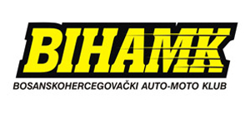 | 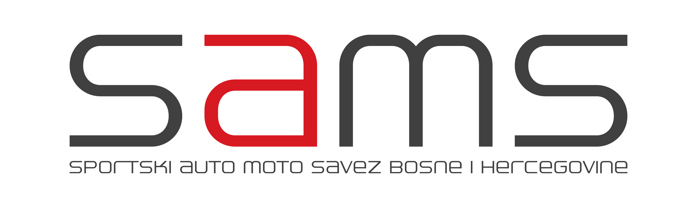

FIA CENTRAL EUROPEAN ZONE
RALLY CHAMPIONSHIP OF BOSNIA AND HERZEGOVINA 2016
RALLY CUP OF BOSNIA AND HERZEGOVINA 2016

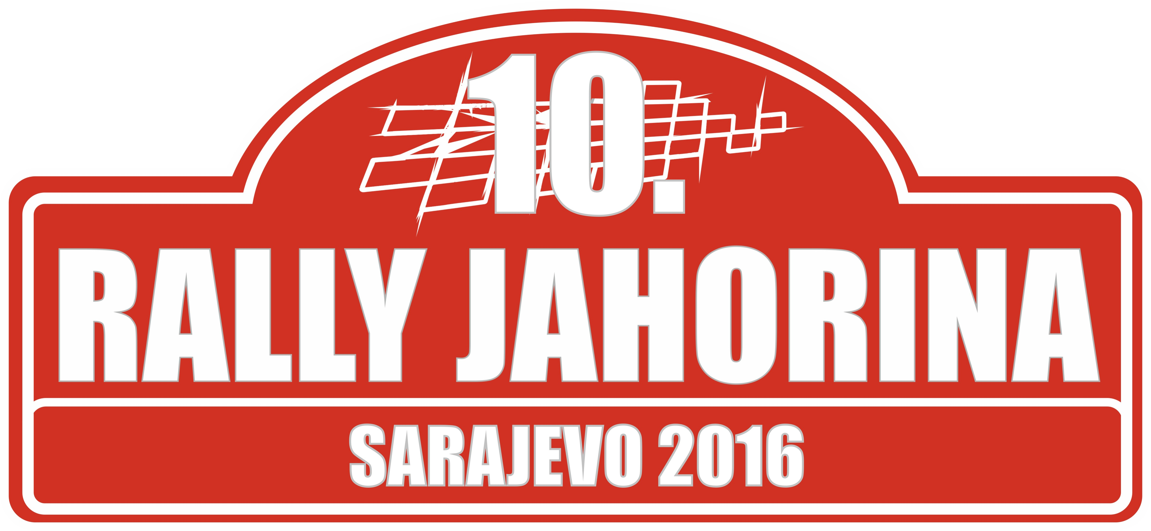

10th Jahorina Rally 2016

SUPPLEMENTARY REGULATIONS

Organizer

„AUTO 4x4 CLUB“
SARAJEVO

October 22-23.2016.

CONTENTS

Page

01. Introduction 3

02. Organization 3

03. Program 4

04. Application 5

08. Insurance 6

09. Advertising and identification 6

07. Tyres 7

08. Fuel 7

09. Reconnaissance of the rally trail 7

10. Verification 7

11. Technical inspection 8

12. Other procedures 8

13. Identification of officials 8

14. Awards 9

15. Final technical inspection 9

Appendix 1 – Itinerary 10

Appendix 2 – Itinerary of trail reconnaissance 12

Appendix 3 – Names and photographs of persons in charge of relations with the competitors 13

Appendix 4 – Competitor's numbers 14

Appendix 5 – Application form 16

1. INTRODUCTION

1.1 Introduction
This Rally is an international competition which is held in accordance with the FIA ​​International Sporting Code and its appendices, 2016 FIA Sporting Regulations for Regional Rally Championships, FIA CEZ Championship Regulations 2016, Regulations A03 and its addition General Regulations of the automobile, motorcycle and karting sport SAMS BIH, rules SAMS BIH which comply with the FIA ​​regulations and these Supplementary Regulations. Changes, additions and / or changes to these Supplementary Regulations will be announced only by numbered and dated Bulletins (issued by the organizer or the Stewards). Additional information will be published in Rally Guide, which will be released October 08 2016. year.
2016 FIA Sporting Regulations for Regional Rally Championships can be found at www.fia.com, FIA CEZ Championship Regulations 2016 on
http://www.osk.or.at/ and ordinances and accessories SAMS Bosnia and Herzegovina can be found on www.bihamk.ba. Rally official language is a B / C / S, so if happens the wrong interpretation of the regulations in other languages, B / C / S version will be taken as authoritative.

1.2 Road surface
Special stages take place entirely on asphalt.

1.3 Total length of special stages and total length of the rally
The total length of the Rally 195,45 km
Number of special stages 6 (3 different trails)
The total length of special stages 57,60 km = 29,47 % of the Rally length.
Number of sections 3
Number of stages 2

2. ORGANIZATION

2.1 Championships in the Rally with awarded scores
FIA Central European Zone
The Rally Championship of Bosnia and Herzegovina 2016
Rally Cup of Bosnia and Herzegovina 2016

2.2 The number of approval
FIA Visa:
SAMS BIH:

2.3 Name, address and contact details of the Organizer

AUTO 4x4 CLUB SARAJEVO
Address: BiH, 71000 Sarajevo, Grbavička 80
Landline: + 387 33 921 100
Mobile: + 387 61 130 330
Fax: + 387 33 922 700
Working hours: 09:00 do 17:00
Website: www.auto.ba
E-mail: auto@auto.ba

Contact person:
Mirko GERH, + 387 33 921 800, + 387 61 130 330

2.4 Organization Committee
Chairman: Mirko Gerh
Members: Ivo Komšić, Nenad Samardžija, Boško Tomić, Drago Talijan, Senad Sefić, Elmedin Bajramović, Ranko Babić, Fadil Čerimagić

2.5 Sporting Committee
Chairman: Pero Maksimović
Member: Mustafa Behlilović
Member: Dušan Savičić

2.6 Rally management
Rally Director: Božo Erak
Assistant to the Rally Director for the sports officiating: Goran Jeremić
Assistant to the Rally Director for safety: Ranko Šunkić
Rally Secretary: Mirko Gerh
Head of the Office and Verifications: Jelena Erak
Head of TKO: Želimir Osenk
Person for relations with competitors: Nedim Gujić
Head doctor: TBA
Head of the Communications Department: Zlatan Šimić
Head of the Press center and Protocol Department : Aleksandar Spasojević

Time measurement and processing of results: TBA
Head of the Measuring department: TBA
Heads of safety of special stages: Milovan Bundalo /SS 3,4/
Almir Mutapčić /SS 1,2,5,6/
Head of Service parking: Braco Tomić

2.7 Location of the office and contact details
Until Friday, October 04 2016 from 09:00 a.m. to 08:00 p.m.:

AUTO 4x4 CLUB SARAJEVO
Address: BiH, 71000 Sarajevo, Grbavička 80
Landline: + 387 33 921 100
Mobile: + 387 66 003 322
Fax: + 387 33 922 700
Working hours: 09:00 do 17:00
Website: www.auto.ba
E-mail: auto@auto.ba
---------------------------------------------------------------------------------------------------------
From Saturday, October 22 2016, to Sunday, October 23 2016, from 09:00 a.m. to 11 p.m.:

Općina Stari Grad, Zelenih Beretki br.4

3. PROGRAM

Last day for applications
Friday, October 14 2016 until midnight.

Issuing of the roadbook
Friday, October 14 2016, from 5 p.m. to 7 p.m. (Stari Grad,Zelenih Beretki br.4)

Anouncement of the list of registered participants
Tuesday, October 18 2016.

Service parking, location and opening
From Saturday, October 22 2016, at 10 a.m., SERVICE PARKING, (Općina Stari Grad, Zelenih Beretki br.4)

Collecting of the materials for the reconnaissance of the rally trail
Friday, October 21 2016, from 5 p.m. to 7 p.m (Općina Stari Grad, Zelenih Beretki br.4)
Saturday, October 22 2016, from 08:00 a.m. to 10:00 a.m. (Općina Stari Grad, Zelenih Beretki br.4)
Rally’s Office: Općina Stari Grad, Zelenih Beretki br.4

Reconnaissance of the trail
Saturday, October 22 2016, beginning at 09:00 a.m.

Rally's Office, working hours
Until Friday, October 21 2016, from 09:00 a.m. to 5 p.m. (AUTO 4X4 CLUB SARAJEVO, Grbavička 80, Sarajevo)
Saturday, October 22 and Sunday, October 23 2016, from 08:00 a.m. to 11 p.m. (Općina Stari Grad, Zelenih Beretki br.4)

Opening of the Press center and accreditation of the media
Saturday, October 22 2016, from 12:00 p.m., Rally's Office: Općina Stari Grad, Zelenih Beretki br.4

Official notice board – location
Rally’s Office and Service parking

Verification of the documents
Saturday, October 22 2016, from 3:00 p.m. to 4 p.m., Općina Stari Grad, Zelenih Beretki br.4

Technical inspection and marking of the car parts
Saturday, October 22 2016, from 3:15 p.m. to 04 :15 p.m., Općina Stari Grad, Zelenih Beretki br.4

The first session of the Sporting Committee
Saturday, October 22 2016, 04 :30 p.m. , Rally’s Office: Općina Stari Grad, Zelenih Beretki br.4

Announcement of the list of accepted participants
Saturday, October 22 2016, 05 p.m., Official notice board

Arrival of the cars to parc ferme (pre-racing parking) for the ceremonial start
Saturday, October 22 2016, from 05:15 to 06:00 p.m., BBI Center, Trg Djece Sarajeva

Ceremonial start and start of the Rally, place and time
Saturday, October 22 2016, at 06:01 p.m., (First vehicle), BBI Center plateau, Trg Djece Sarajeva, Sarajevo

Podium ceremony/Awards ceremony
Sunday, October 23 2016, at 05:00 p.m. , (First vehicle) Finish line: BBI Center, Trg Djece Sarajeva, Sarajevo

Final technical inspection
Sunday, October 23 2016, from 05:30 p.m., Općina Stari Grad, Zelenih Beretki br.4

The second session of the Sporting Committee
Sunday, October 23 2016, at 06:00 p.m. Rally's Office: Općina Stari Grad, Zelenih Beretki br.4

Time of the announcement of preliminary results
Sunday, October 23 2016, at 06:30 p.m., on all notice boards

Time of the announcement of final results
Sunday, October 23 2016, at 07:00 p.m., on all notice boards

4. APPLICATIONS

4.1 Last day for applications
Friday, October 14 2016, until midnight.

4.2 Application procedure
Everyne who would like to participate in the „ 10th Jahorina Rally 2016“ must send the fully completed application form which has to be sent to the Rally's Office no later than October 14 2016 by midnight. The application can be sent by post:

AUTO 4X4 CLUB SARAJEVO
Grbavička 80, 71000 Sarajevo
or fax: + 387 33 922 700
or email: auto@auto.ba

Details concerning the co-driver can be sent by October 22 2016 (verification of the documents). If the application form is sent by fax or email, the original form must be delivered to the Organizer no later than October 22 2016 at 10:00 a.m.
Applications where the competitor is not the member of the team must be accompanied by the copy of the corresponding competitor's license.

4.3 Number of participants and class of vehicles
The maximum number of registered competitors is 30

RALLY CHAMPIONSHIP OF BOSNIA AND HERZEGOVINA
RALLY CUP OF BOSNIA AND HERZEGOVINA

In accordance with Article 9 of the 2016 A03 Regulations on automobile rally, SAMS BiH, the vehicles are grouped as follows:

DIVISION | GRUPE
Overall standings | N4 over 2001 ccm with 33 mm restrictor  HN4 (expired homologation FIA N4)  S3 over 2001 ccm
1 | A7 (1601 ccm to 2000 ccm)  Super 1600  R2C (1601 ccm to 2000 ccm)  R3C (1601 ccm to 2000 ccm)  R3T (up to 1601 ccm nominal engine displacement)  A6 (1401 ccm to 1600 ccm)  R2B (1401 ccm to 1600 ccm)  Kit Car (1401 ccm to 1600 ccm)  HA7 (expired homologation FIA A7)  HA6 (expired homologation FIA A6)  Diesel group A with turbocharged engines (up to 2000 ccm nominal engine displacement)  R3D (up to 2000 ccm nominal engine displacement)  S2 (1401 ccm to 2000 ccm)S2 (1401 cm³ do 2000 cm³)
2 | N3 (1601 ccm do 2000 ccm)  HN3 (expired homologation FIA N3)  Diesel group N with turbocharged engine (up to 2000 ccm nominal engine displacement)
3 | N2 (1401 ccm to 1600 ccm)  R1B (1401 ccm to 1600 ccm)  HN2 (expired homologation FIA N2)
4 | A5 (to 1400 ccm)  Kit Car (to 1400 ccm)  N1 (to 1400 ccm)  R1A (to 1400 ccm)  HA5 (expired homologation FIA A5)  HN1 (expired homologation FIA N1)  S1 to 1400 ccm

Vehicles homologated as Kit cars, with the capacity between 1400 and 1600 ccm, will be accepted only if they are in accordance with the Article
255-6,2 "Weight" Appendix J.
Vehicles powered with alternative fuels (diesel, biodiesel, bioethanol, gas), on two wheels with a turbocharger whose nominal value of the cylinder capacity is below 2000 ccm, can race in groups N and A.
Group A vehicles with a corrected volume of cylinder below 2000 ccm must have homologation approved by the regional FIA.

4.4 Entry fee

DEADLINE | Division 4 | Divisions 2 & 3 | Division 1 + overall standings
At the competition's verification | 100,00 KM (50 €) | 150,00 KM (75 €) | 200,00 KM (100 €)

Private competitors are those where the driver is also the competitor (an individual), as opposed to competitors who are legal entities (club, team, ...).
Amounts relate to applications with the obligatory organizer’s advertisement.
The amount of the entry fee for competitors who do not accept the obligatory organizer’s advertisement is 500,00 KM (250 €).

4.5 Payment information
Applications will be accepted only if the total entry fee has been paid or if confirmation receipt has been issued by the national association, unless the organizer decides differently.

Entry fees are to be deposited in the account below:

Remittance in domestic currency (KM):

UniCredit bank DD, Račun: 3389002208908043
U.G. Auto 4x4 Club – Grbavička 80, 71000 Sarajevo, BiH
PDV broj: 200231980001 Tax reference number: 01704119

Remittance in foreign currency (EUR):

UniCredit bank DD, IBAN BA393387204809083544, SWIFT UNCRBA22
U.G. Auto 4x4 Club – Grbavička 80, 71000 Sarajevo, BiH
PDV broj: 200231980001 Tax reference number: 01704119
Application confirmation receipt should be sent to the organizers along with the application form.

4.6 Refund policy
Entry fee will be returned in full to the competitors whose application was not accepted or to all participants in case that the Rally does not take place. Organizers will return 50% of the entry fee to competitors who were not able to participate in the competition due to “greater force” (with the confirmation from their national association).

5. INSURANCE

Insurance description:
Insurance cover guarantees the competitor’s cover for civil liability towards third parties up to the amount of 30.000 KM for people and things. Every competitor must have an insurance for their rally car, and at the request of the competitor Organisers will, at competitor’s cost, arrange any additional insurance during the Rally.
Service and team vehicles, including vehicles with license plates of the organizers, are not considered to be the official vehicles of the Rally. Therefore, they are not covered by insurance and are the sole responsibility of their owners.

6. ADVERTISING AND IDENTIFICATION

All advertising must comply with the laws of Bosnia and Herzegovina.

Obligatory advertising of the organizers will be placed on competition numbers and rally plates.

Optional additional advertising will be placed as shown in Appendix 4.
If the driver refuses the optional additional advertising from the Organizers, he/she must pay the entry fee in the amount of 300,00 KM (150 €).
Details about advertising during the Rally will be published in the Newsletter.

The Organizer reserves the exclusive right to place any kind of advertising, displaying advertisements, banners, flags etc.. This right is also reserved for giving out advertising or promotional materials in the Office, Service parking, the start and finish area and along the route of the Rally.

Any kind of advertising by the crews, competitors, clubs and teams must be approved by the Organizer.

Competition numbers
Competition numbers supplied by the Organizer must appear on the car, in compliance with Appendix 4, for the entire duration of the Rally. If it is determined that the competition number is missing at any time of the competition, that will be reported to the Sporting Committee, who may impose penalty in accordance with Articles 12.3. and 12.4. of the ISC.

Rally plates
Rally plates must be affixed on the vehicle as shown in Appendix 4 during the entire Rally. The front plate must not, under any circumstances, even partially, cover the registration plate of the vehicle.
Such an infringement will be reported to the Sporting Committee who may impose penalty in accordance with Articles 12.3. and 12.4 of the ISC.

7. TYRES

  - Use of tyres during the Rally
There will be no special tyres used during the Rally.
Rally tyres must comply with the specifications in Article 60 of the FIA Sporting Regulations for the Regional Rally Championship 2016. The use of tyres homologated before May 01 2013 is allowed.

7.2 Tyres for use on reconnaissance
Tyres used for reconnaissance must comply with the specifications given in Article 25.2 of the FIA Sporting Regulations for the Regional Rally Championship.

  - National laws or special requirements
There are no special laws and requirements for tyres in Bosnia and Herzegovina.

8. FUEL

Fuel and refueling for the Rally is in accordance with Article 58 of the FIA Sporting Regulations for the Regional Rally Championship 2016.

  - Ordering procedure
There will be no ordering of fuel for this Rally.

  - Closing date for ordering FIA fuel
There will be no ordering of fuel for this Rally.

  - Distribution of fuel for non-priority drivers
There will be no distribution of fuel for this Rally.

9. RECONNAISSANCE OF THE TRAIL

9.1 Registration procedure
All the material related to the reconnaissance will be available to the crews in the directorate of the Rally from Friday, October 21 2016, from 05:00p.m. to 07:00p.m. and on Saturday, October 22 2016, from 08:00a.m. to 10:00a.m. (Općina Stari Grad, Zelenih Beretki br.4)

When registering for the reconnaissance, one of the team members must complete an information sheet giving details about the reconnaissance vehicle, mobile phone number and the place of temporary residence for the duration of the Rally.
Insurance for the reconnaissance vehicle must be presented during the registration process.
The assigned number for the reconnaissance vehicle must be placed at the top center of the windscreen and must be visible for the entire duration of the reconnaissance.

Reconnaissance period is on:
Saturday, October 22 2016. from 09:00a.m. to 04:00p.m.

9.2 Specific and/or national limitations – speed limit at the special stages
9.2.1 Any kind of practice on the rally route is forbidden.
9.2.2 Throughout the entire reconnaissance, the crews must strictly observe the traffic laws of Bosnia and Herzegovina, which generally correspond to those in continental Europe.
Unless it is otherwise specified by traffic signs, the maximum permitted speed in inhabited areas is 50 km/h, in non-inhabited areas it is 80 km/h, and on highways 130 km/h. Headlights must be turned on at all times. The use of radar detectors is not allowed.

9.2.3 During the reconnaissance, the crews will not have a limited number of passages on each special stage.
9.2.4 Crews are required at the start of special stages to present their time cards for the reconnaissance.
9.2.5 During the reconnaissance of special stages, the crews are not allowed, under any circumstances, to drive in the opposite direction of the special stages.
9.2.6 Each crew member who is the participant of the „10th Jahorina Rally 2016“, and is found on the special stages of the rally before Saturday, October 22 2016, and/or outside the reconnaissance schedule, will be treated as an individual illegally performing reconnaissance.
9.2.7 Organizers will regularly monitor the routes of special stages.
9.2.8 Any infringement of the reconnaissance regulations and given schedule will be considered a very serious offense, and a report will be submitted to the Sporting Committee who will discuss the case at hand and impose a penalty which may go as far as prohibiting to race.

  - Installation of speed control device
Speed control devices will not be installed in reconnaissance vehicles, however, the police will control the speed on the special stages. Any violation of the speed limit will be reported to the Sporting Committee.

10. VERIFICATION

10.1 Documents to be presented:
- Competition license
- Driver's and co-driver's license
- Driver's license for the driver and co-driver
- Driver's and co-driver's passport or ID card
- Fully completed application form
- Insurance cover for the rally car
- Registration of the rally car
- Valid medical card for the driver

10.2 Schedule
Verification will take place on Saturday, October 22 2016, from 3:00p.m. to 04:00 satip.m., Općina Stari Grad, Zelenih Beretki br.4
There is no specified schedule for the verification of crews during the previously mentioned time.

11. TECHNICAL INSPECTION

11.1 Location and schedule
The technical inspection will be held on Saturday, October 22 2016, from 3:15 p.m. to 04:15 p.m., Općina Stari Grad, Zelenih Beretki br.4

11.2 Mud flaps
The installation of mud flaps is allowed in accordance with the Article 252-7.7. Appendix J.

11.3 Windows
The windows must be certified for road use, and in accordance with Appendix J, Article 253.11.
For the vehicles in group S , the use of 3-mm thick polycarbonates is allowed, instead of side and rear glass.

11.4 Safety equipment
The control of helmets and driver’s equipment will take place during the technical inspection. The helmets must be in accordance with the rules listed in the FIA Technical List No.25, Appendix J. For drivers, wearing gloves is mandatory (not mandatory for co-drivers), as well as underwear, socks, shoes and protective overalls, which comply with the FIA 8856-2000 Standard. The validity period for the homologation equipment FIA 8856-2000 is not limited. Using HANS® system which comply with the FIA 8858-2002 standard according to the FIA Appendix L, Chapter III, Article 3 of the mandatory for competitors with licenses SAMS BiH. For drivers with foreign licenses use of the HANS system is in accordance with the regulations for A03 discipline their ASN.

11.5 Noise level
For safety reasons, during the special stages, it is recommended to use the exhaust silencer, provided that the emission of exhaust gases is in accordance with Appendix J, and for vehicles with catalytic converter that the exhaust gases pass through the catalytic converter. The noise level must always be in accordance with Appendix J.

11.6 Special national requests
Competition vehicles must arrive to the technical inspection with affixed rally plates, competition numbers and Organizer's advertising.

Every late arrival to the technical inspection (in relation to the schedule given in the confirmation receipt) will be penalized:
- up to 30 min 30,00 KM
- 30 to 60 min 100,00 KM
- over 60 min 200,00 KM + penalty imposed by the Sporting Committee

11.7 Installation of the safety tracking device
There will be no installation of the safety tracking device.

12. OTHER PROCEDURES

12.1 Ceremonial start and schedule
Saturday, October 22 2016, starting at 06:01p.m. , (first vehicle), BBI Center plateau, Trg Djece Sarajeva, Sarajevo. All crews will start according to the starting list.

12.2 Closing procedures
The competition part of the Rally finishes with the control TC 6A .

12.3 Allowed earlier entrance
The crews are allowed earlier entrance (before planned time) in time controls, TC 6C and TC 6D without penalties.

12.4 Procedure at the start of special stages
After the starter hands the crew the time card with the starting time, he directs their attention to the clock which shows the time in hours, minutes and seconds, and has a red light on. 30 seconds before the starting time, the clock will begin the countdown of the remaining seconds. 5 seconds before the starting time, the light will change from red to yellow. The starting time is signaled by the green light which is synchronized with the beginning of the minute of starting time on the clock. The photocells of the measuring device with a printer are placed on the starting line, and they are synchronized with the above mentioned system, which registers false start.

12.5 Special procedures/activities, including the promotional activities of the Organizer

Pre-racing parc ferme
Before the ceremonial start there will be organized the pre-racing parc ferme, BBI Center plateau, Trg Djece Sarajeva.
All vehicles must enter into the parc ferme area between 04:30p.m. to 05:00p.m.
Drivers must wear the protective overalls.

Service parking
Service parking will be placed at the Ars Aevi plateau, Vilsonovo šetalište bb
Due to safety reasons, it is strictly forbidden to use open flames, gas or electric cookers, barbecues etc. in the area of the Service parking.

12.6 Official time at the competition
Official time during the Rally is given when calling the number 125.

13. IDENTIFICATION OF OFFICIALS

Judges: Orange tabard shirt with a printed sign
Head of safety: Orange tabard shirt with a white stripe and printed sign
Head of judges: Blue tabard shirt with a white stripe and printed sign
Media: Green tabard shirt
Head of BI: Red tabard shirt with a printed sign
Relations with competitors: Red tabard shirt with a printed sign
Doctor: White tabard shirt with a printed sign
Radio: Yellow tabard shirt with a printed sign and a blue mark
Technicians: Black tabard shirt with a printed sign
Stewards: Grey tabard shirt

14. AWARDS

Awards will be given in accordance with the Article 36. of the Regulations on automobile rally A03 SAMS BIH and its appendix.

15. FINAL TECHNICAL INSPECTION

15.1 Final technical inspection
Immediately after crossing the finish line, cars selected by the Sporting Committee will be finally checked and inspected at the Ars Aevi plateau, Vilsonovo šetalište bb. The final technical inspection starts on Sunday, October 23 2016. at 5:30p.m. The crews are obliged to abide by the instructions of the Organizer. At least one representative of the competitors and a sufficient number of the team's mechanics (in the event of any necessary work on the vehicle) must attend the final technical inspection.

15.2 The complaint fee
The complaint fee is determined by SAMS BIH and it amounts to 500,00 KM (250 €).
If it is necessary to disassemble and re-assemble certain car parts, the claimant must pay an additionl deposit of 500,00 KM (250 €) if the complaint relates to one of the car parts (engine, transmission, steering, brakes, electronics, bodywork etc.). If it is determined that the complaint was unfounded , the costs incurred by the works and transport of the car will be borne by the claimant. Otherwise, if the complaint is justified, the costs will be borne by the competitor against whom the complaint was filed. If the complaint is unfounded, and the expenses incurred by disassembling, re-assembling and transport are higher than the deposit amount, the amount is paid by the claimant. Conversely, if the expenses are less than the deposited money, the amount is returned to the claimant.
The Sporting Committee can define a higher deposit, if deemed as necessary.

15.3 The appeal fee
The fee for appealling to SAMS BIH is 1.000,00 KM (500 €).
The fee for appealling to FIA is 6.000 €.

RALLY SECRETARY RALLY DIRECTOR
Mirko Gerh Ivan Jevtić

PRESIDENT OF SAMS BiH
Aleksandar Brkić

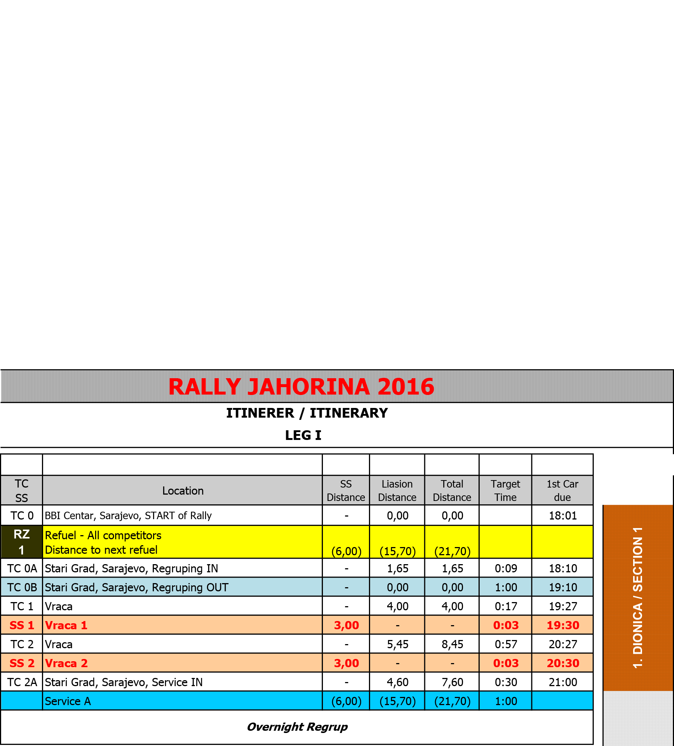
APPENDIX 1

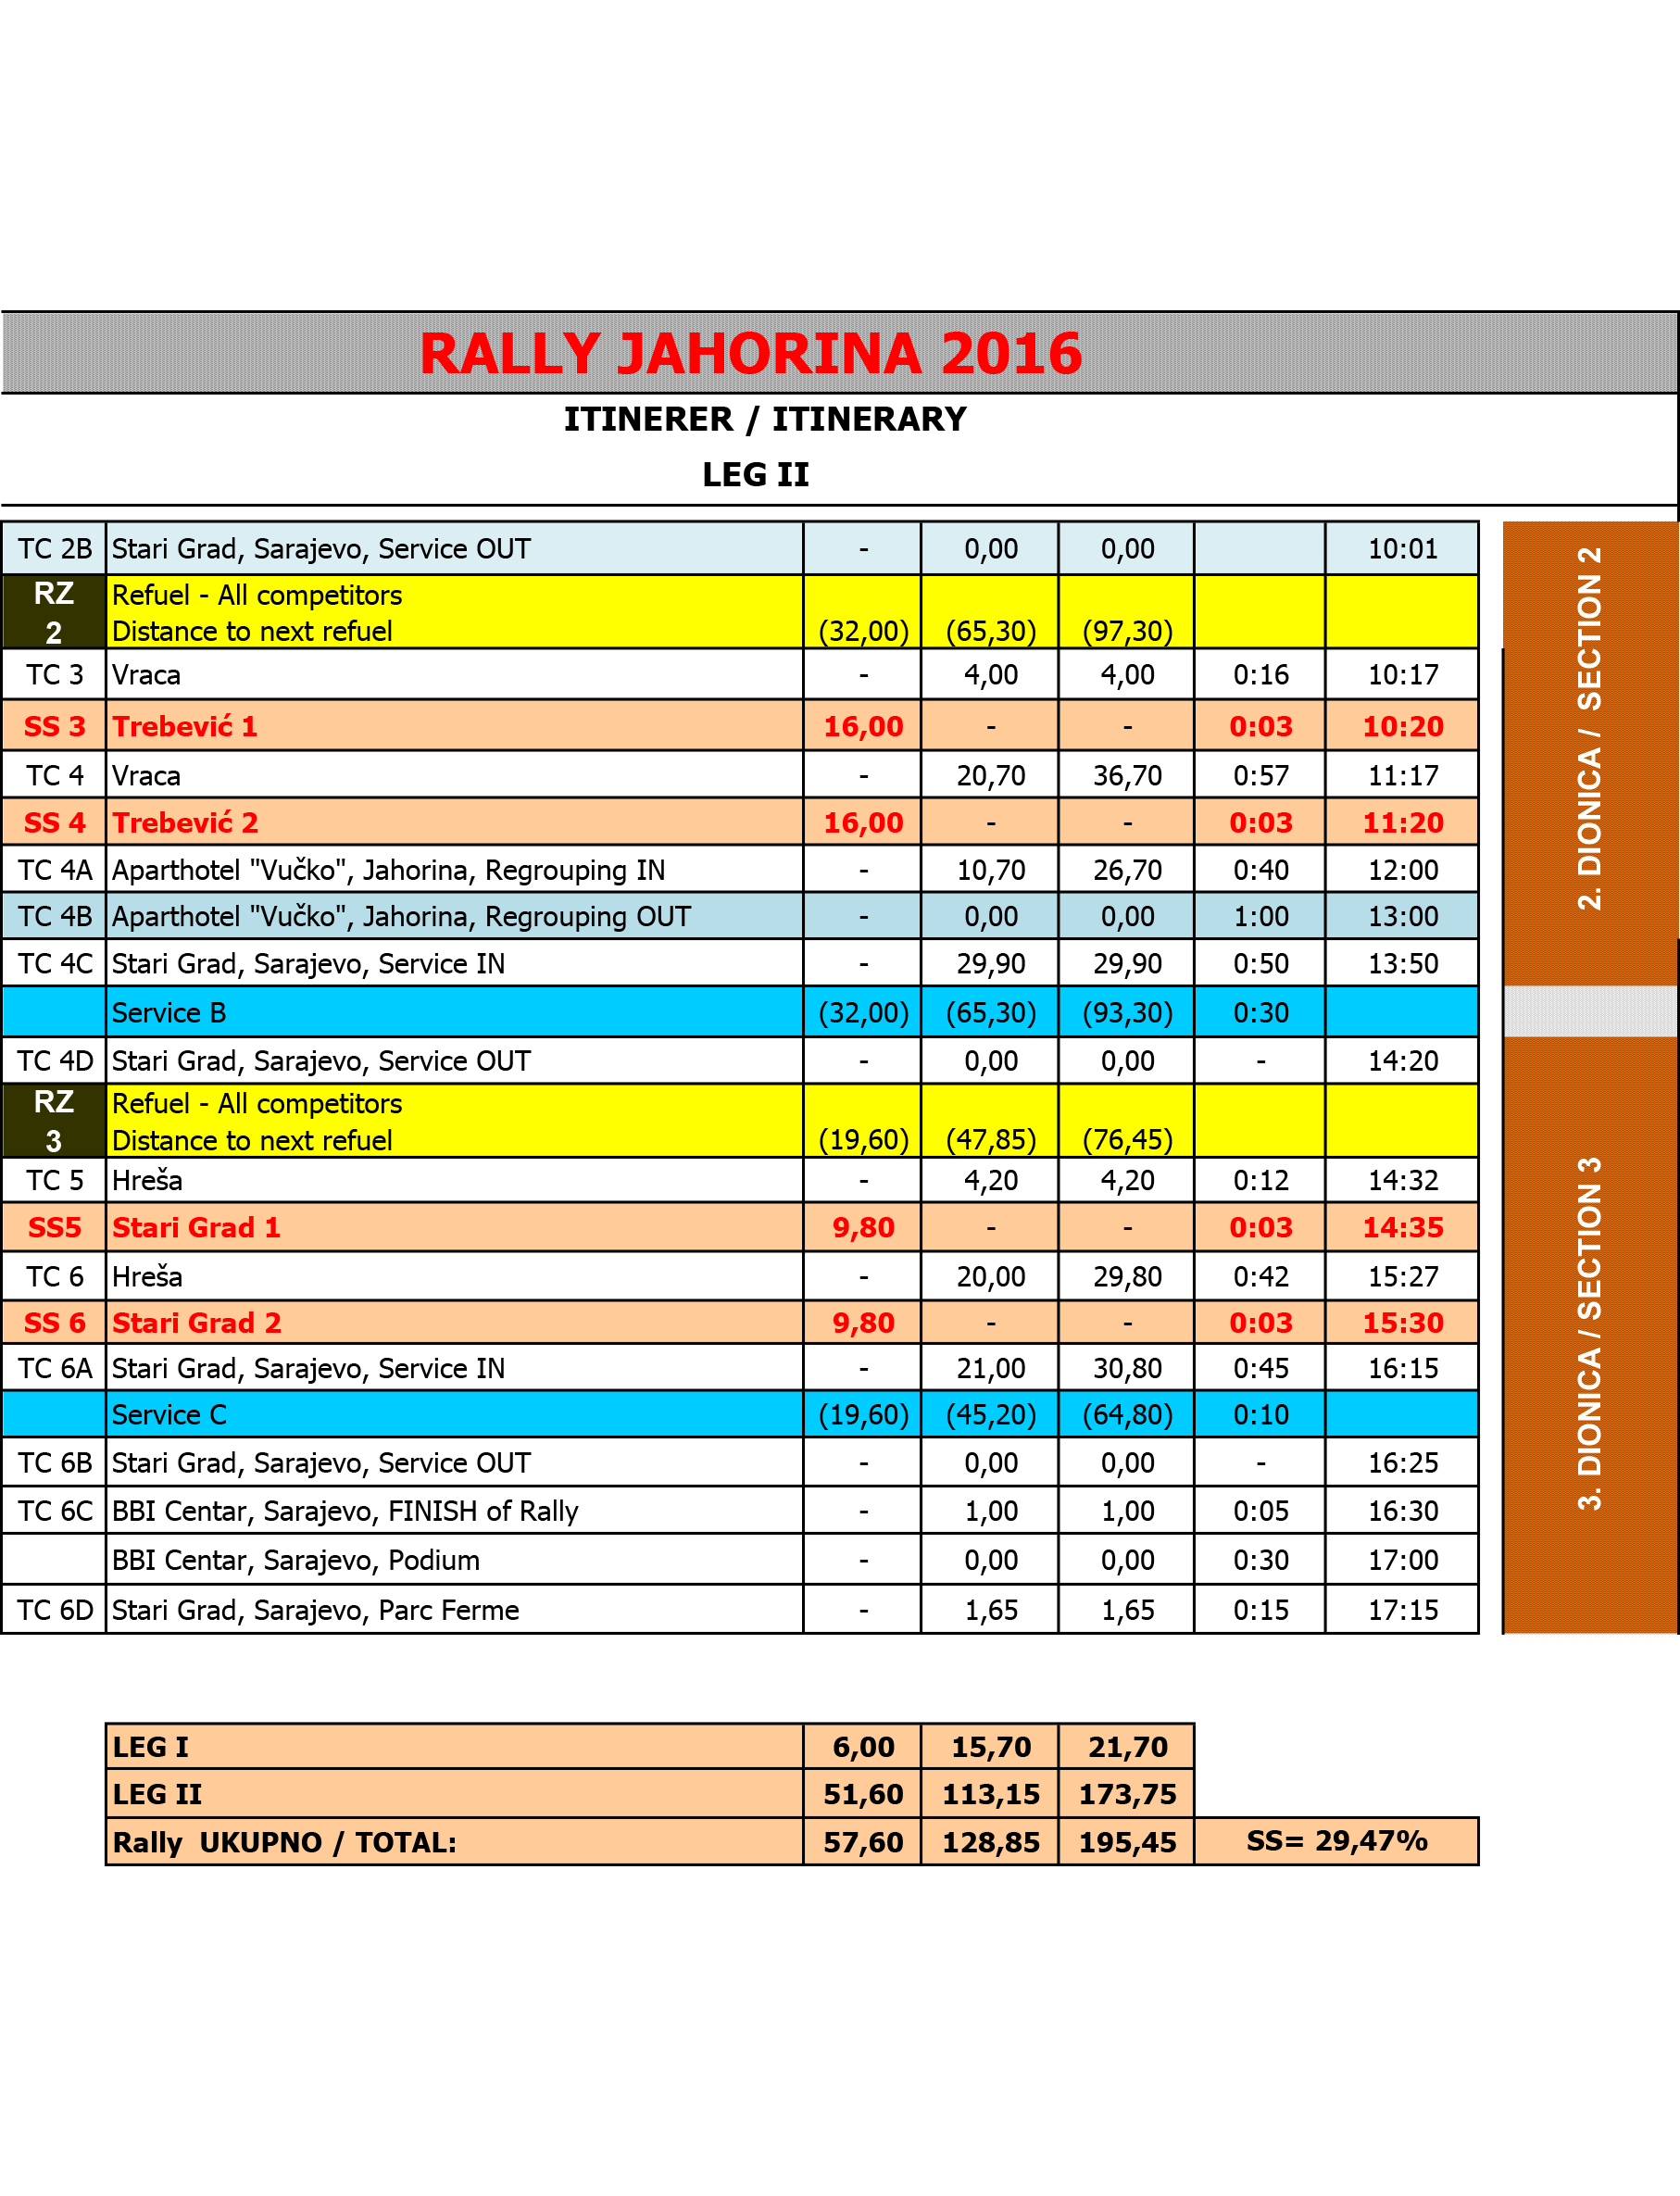
APPENDIX 1

APPENDIX 2

Control judges will be present during the reconnaissance of the trail, at the start of the Rally and at the recording of every special stage. Additional controlling at the trail for special stages is also possible.

The itinerary for the reconnaissance of the trail

The reconnaissance will be allowed according to the following schedule:

Saturday, October 22 2016.

09:00a.m. – 12:00p.m. Special stages 1, 2, 3, 4 (Vraca, Trebević)

12:00p.m. – 04:00p.m. Special stages 5, 6, (Stari Grad)

Moving in the direction opposite of the determined direction of special stages is strictly forbidden to crew members!

Any infingement of the reconnaissance regulations and given schedule will be considered a very serious offense and a report on the matter will be submitted to the Sporting committee which will discuss the matter at hand and impose a penalty which may go as far as prohibiting participation in the race!

APPENDIX 3

I am the person in charge of relations with the competitors:

NEDIM GUJIĆ
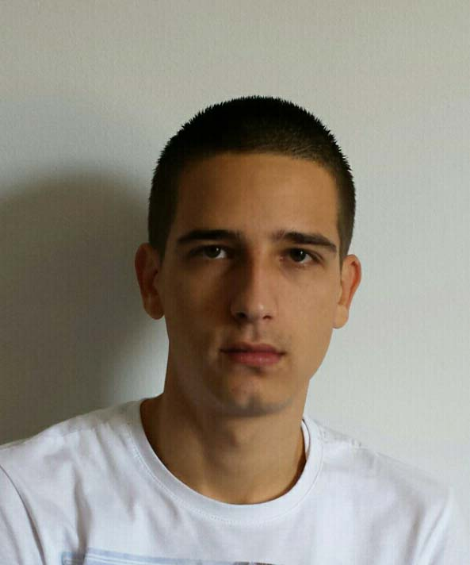
Mobile: 00387/61/765-024

During the competition I will be wearing a red tabard shirt with the print „Relations with drivers”.

The drivers will be able to find me in following locations and according to the following time schedule:

Saturday, October 22 2016
- from 12:00p.m to 05:00 p.m. and from 06:30p.m. to 09:00p.m., in Rally Office (Direction) and at the Service parking
- from 05:30p.m. to 07:00 p.m. at the parc ferme (pre-race parking) and start podium

Sunday, October 23 2016.
- from 08:00a.m. to 04:30p.m. and from 06:30p.m. to 09:00p.m, at the Service parking
- from 05:00p.m to 06:00p.m., at the finish podium

APPENDIX 4

COMPETITORS NUMBERS

The Organizer will provide each crew with a number, which must be affixed to their rally car, before the technical reception, in the following way:

1. COMPETITION NUMBERS
1.1 Two front door panels must be 67 cm wide and 17 cm high, including 1 cm of white edges. Each of these panels will contain the 15 x 15 cm space for the competition number, which will be placed at the front of the plate at all times. When the competition number is higher than 99, the width of the panel can be extended. Numbers must be fluorescent yellow (PMS 803), 14 cm high with the 2-cm thick line on a matt black background. The rest of the panel is reserved for the Organizer.

1.2. Each panel will be placed horizontally at the edge of each front door, with the number at the beginning. The top of the plate will be 7-10 cm below the lower line of the window.

1.3. No marks, except for the colored pattern of the car, are to be placed within 10 cm from the panel.

1.4. One rear window panel which must be 30 cm wide and maximum 10 cm high, is reserved for the Organizer. This panel will be placed on top of the rear window, and positioned in the left or right corner, depending on what is written in the Special Regulations for the competition. The surrounding area of 15 cm² will contain a 14 cm high competition number of fluorescent orange color (PMS 804) on a clear background. This number can be reflective and must be visible from the rear at eye level.

1.5. Two numbers for each rear window must be 20 cm high, with the width of the line of at least 25 mm, colored fluorescent orange (PMS 804), and can be reflecting. Those numbers must be placed on top of the rear side windows, together with the names of the driver/crew.

1.6. For the front of the vehicle – rally plates: one rectangular panel 43 cm wide and 21.5 cm high, which will contain the competition number and the full name of the Rally. The Organizer of the Rally Cup is obliged to make all numbers in the basic version of the specified color (less important is the type of color and the mark).The Organizer of the Rally Cup is allowed to prescribe the obligatory sticker of up to 50 x 14 cm, which crews place on the left (one) and on the right(one) side of the vehicle in the space available, excluding the glass surfaces, and respecting the right of pre-given space for labels and stickers.

2. DRIVER'S AND CO-DRIVER'S NAMES
2.1. The first and last name of the driver and co-driver, together with the flag of the national association whose license the drivers possess, must be placed on the rear side window on both sides of the car, below the competition number. The names must be written in: - white Helvetica font: - uppercase letters-first letters of name and last name, and the remainder in lower case - 6 cm high with the width of the line of 1,0 cm. The driver's name will be on top on both sides of the car. If it is established that during the Rally some car is missing the rally plate or number, or the panel or shape do not correspond to the prescribed rules, the crew will be fined. If both rally plates or numbers are missing the crew will be excluded.

3. ORGANIZER'S ADVERTISING LABELS
The Organizer is entitled to place four advertising labels on each competing car, of rectangular chape, 50 cm wide and 15 cm high. The labels must be placed sideways on the car, two on front and two on rear fenders.

The crew has the right to refuse promoting these labels with the obligation of paying the entry fee in the amount of 500,00 KM (250 €).

STICKERS FOR DOORS AND COMPETITION NUMBERS


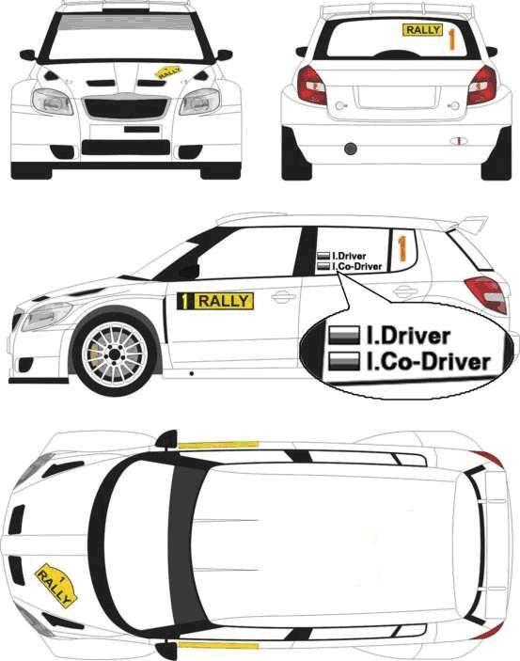

APPENDIX 5

APPLICATION FORM

Starting No:
 | COMPETITOR - CLUB | DRIVER | CO-DRIVER
Name
Last name
First name
Pseudonym
Date of birth
Nationality
Address
Contact address
Landline phone no. (work)
Landline phone no.(home)
Mobile
Fax
E mail
Driver’s license no.
Competitior’s license no.
National Association
Issuing country

VEHICLE INFORMATION
Mark |  | Registration country
Model |  | Registration number
Year of production |  | Engine displacement (ccm)
Class |  | Chassis number
Homologation number |  | Driving license number

I’m applying for: | FIA CEZ |  | CH BiH |  | C BiH

Organiser’s proposed advertising accepted (choose): | YES | NO

ENTRY FEE
Deadline | Division 5 | Division 2, 3 and 4 | Division 1
14.10.2016. unitil midniht | 100,00 KM (50 €) | 150,00 KM (75 €) | 200,00 KM (100 €)

PRIORITY INFORMATION

Driver: _____________________________________________ Vehicle: __________________________________

Class: _______________________________

FIA Priority A YES/NO Prior FIA priority YES/NO
FIA Priority B YES/NO If yes, year ________
National prirority YES/NO Priority ________
Winner of national championship YES/NO If yes, championship ________________ year ________

Year |  | Competition | Vehicle | Group | Final ranking | Class | Finishing competitors
International
National
Other

STATEMENT ON COMPENSATION
Competitor - club driver and co-driver, along with the accompanying crew accept and agree with the following:
- We are familiar with and we will abide and be bound by the rules of the Regulation for the 9. Rally Jahorina 2016,the competition which is being held according to the regulations of the International Sporting Code, Sporting and Technical Regulations of the FIA, the Regulations on motor sports SAMS BiH.
- We understand that motor sports are dangerous and that accidents can cause death, bodily harm, property damage and that by accepting this application, no one, neither FIA, nor SAMS BiH, nor the ORGANIZER nor any official person at the competition is liable for death, bodily harm or damage to the property caused by our participation at the 9th Jahorina Rally 2016.

The driver is responsible for any possible failure to comply with the FIA and/or SAMS BiH Regulations, both on his/her behalf and on behalf of all other persons who were in any way connected with the driver’s performance in the competition.

STATEMENT AND ACCEPTANCE
With my signature I guarantee that all the data given in the application form is accurate and I fully recognize and accept the above stated conditions of compensation, and I accept the conditions relating to my participation in this competition.
Signature of the association * | Signature of the competitor – club | Signature of the driver | Signature of the co-driver

* Or the letter from the applicant’s national association allowing the application

Date ___________________________________

